带有GB/T27930 CAN接口的ISO/IEC15118 电动汽车充电通讯解决方案
ISO/IEC15118 EV Charging Communication Solutions
with GB/T27930 CAN Interface

RNL 是一家电动汽车充电通信解决方案的领军供应商。RNL的通信通信调制解调器与ISO/IEC15118, SAE2847-2及 DIN70121
都兼容。
RNL is a leading provider of EV Charging communication solution.
RNL’s EV Charging Communication Modems are compliant to ISO/IEC15118, SAE2847-2 and DIN70121.

2

被全球电动汽车制造商验证过的解决方案
Solutions are verified by Global EV makers

RNL的电动汽车通信解决方案被全球的电动汽车制造商和电动汽车充电桩供应商测试过。
RNL EV Charging Communication Solution was tested with Global Car Makers and EV Charger Solution providers.

HYUNDAI
} GM

} VOLKSWAGEN
} BMW

} FORD
} HONDA
} NISSAN

} Sumitomo, Denso, TUDortmunt, AUDI, TMG, LGInnotek, …

3

ISO/IEC15118 电动车充电软件结构

Multi-V2GTP
Multi-SLAC
Multi-SDP

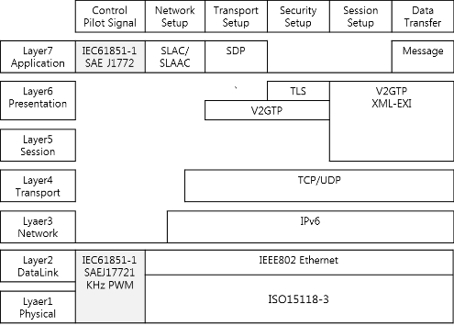4

ISO/IEC15118 电动汽车充电序列

CP Status
Cp 状态
Power ON Initialization PLC module
Description of Charging sequences
充电序列描述

* red character: can be loop for sometimes because EVSE or EV may take a time to finish that special event.
State A1 State B1 State B2

Coupler connection Coupler connection

Initialization
- Proximity Detection by EV
- CP Status Change Detection by PLC
- Digital Comm. check - Duty ratio 5%
- V2GTP Start
- SLAC
- SDP
- Support Application Protocol & result
- Session Set up & result
- Service Discovery & result
- Service Payment selection & result

connector locked by EV
State C2

Cable Check
  - Contract Authorization & result
  - Charge Parameter Discovery & result

  - Cable Check & result
EVSE shall execute isolation check max. within 30 seconds.

Pre-charge

Delivery Energy
- Pre-charge & result
- Power Delivery & result (Request Energy)

- Current Demand & result

State B2 State B1

Finish
  - Power Delivery & result

  - Welding Detection & result
  - Session Stop & result
5

GQ EVSE & EVCC 板

带有HomePlug Green PHY PLC的ISO/IEC15118软件整体解决方案
Turnkey solution of ISO/IEC15118 Software with HomePlug Green PHY PLC
GQ-EVCC-xxV-用于电动汽车
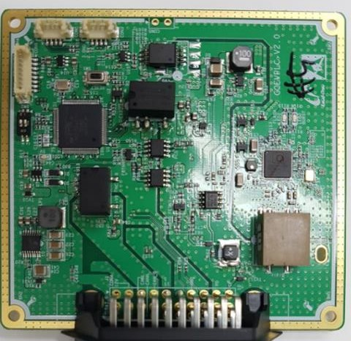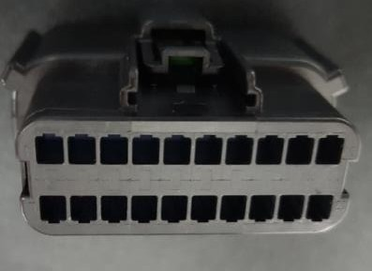GQ-EVSE-xxV –用于电动汽车充电桩
Power
PD
CAN Low
CP
1
10
11
20
CAN High PE
Gnd

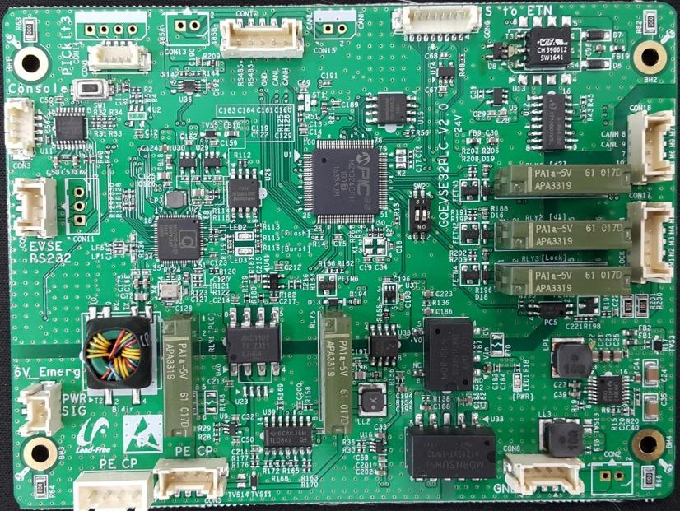
CAN
Power
CP/PE
Console (RS232)

RNL解决方案选型指南

Target Application 目标应用 |  | EV Charger 电动汽车桩 |  | EV & E-BUS 电动车&巴士
Product Name 产品名称 |  | GQ-EVSE_1 | GQ-EVSE_2 | GQ-EVCC_1 | GQ-EVCC_2
Part Number料号 |  | GQEVSE32PLC-12V | GQEVSE32PLC-24V | GQEVPLC-36V | GQEVPLC-24V
Dimension  尺寸 |  | 120 x 88 mm | 120 x 88 mm | 97 x 90 mm | TBD
Main  features 主要特征 | Charging Protocol | GB/T27930 ßàCCS  Conversion | GB/T27930 ßàCCS  Conversion | GB/T27930 ßàCCS  Conversion | GB/T27930 ßàCCS  Conversion
 | PLC | √ | √ | √ | √
 | RS232 or RS485 | √ | √ | - | -
 | PWM 1KHz | √ | √ | - | -
 | CP_Level | √ | √ | - | -
 | CAN_ISO | √ | √ | √ | √
 | CAN2 | √ | √ | - | √
 | CHAdeMO | - | √ | - | -
 | PD, Duty, 9Và6V | - | - | √ | √
 | Connector Lock | - | - | - | √
 | K3/K4 Control | - | - | - | √
Input  Voltage 输入电压 | Min. | 6V | 13V | 6V | 13V
 | Typ. | 12V | 24V | 24V | 24V
 | Max | 36V | 36V | 36V | 36V
Availability  可供性 |  | Available now 可供 | Available now可供 | Available now 可供 | TBD待定

电动汽车充电通信软件
EV Charging Communication Software
RNL-SEStack
§ ISO/IEC15118, SAE2847-2, DIN70121 support.
- Support multi-EV in parallel. 并行支持多车
- Error handling for all exceptions. 对所有异常的错误处理
- Easy Control & Monitoring using RS232/RS485/CAN . 用
RS232/RS485/CAN易于监控
- Verified by Compliant test with global Electric Vehicle companies通过全球电动汽车公司的验证测试

RNL-EVStack
§ ISO/IEC15118, SAE2847-2, DIN70121 support.
  - Error handling for all exceptions.对所有异常的错误处理
  - Easy Control & Monitoring using CAN 用CAN易于监控

8

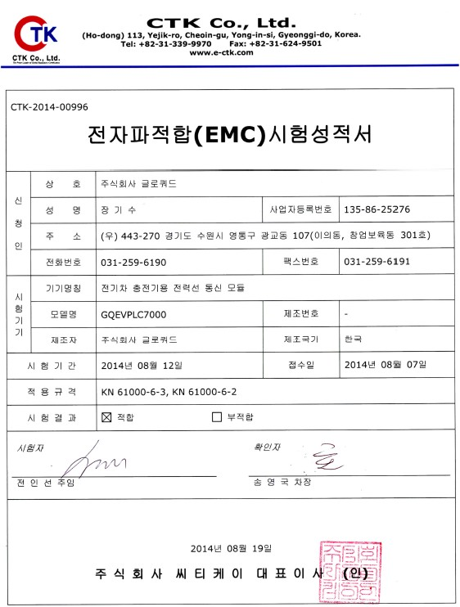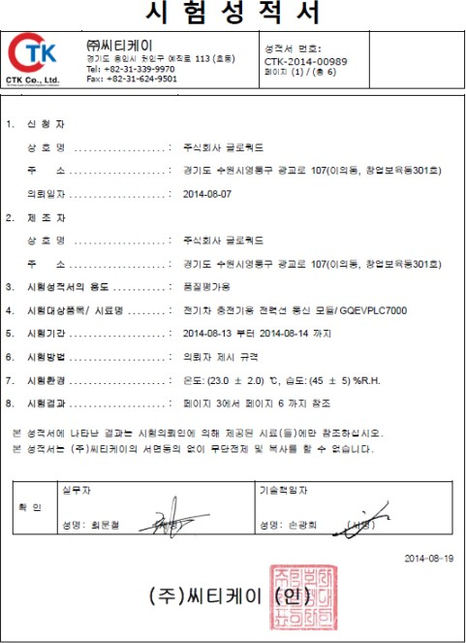产品测试报告
EMC Test Report
Reliability Test Report (-40 ~ +85 Temp.)

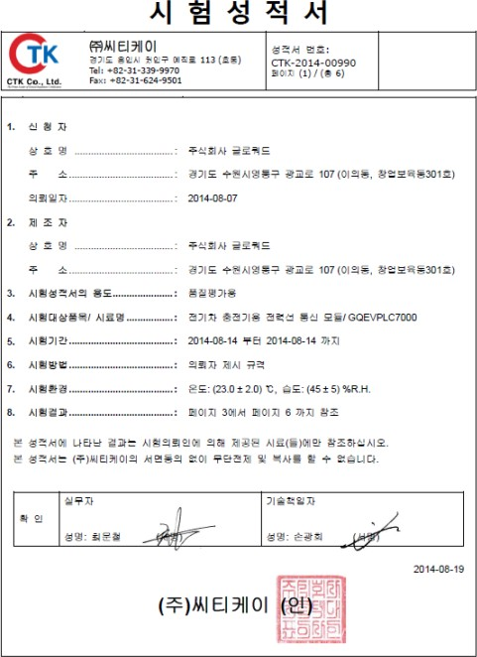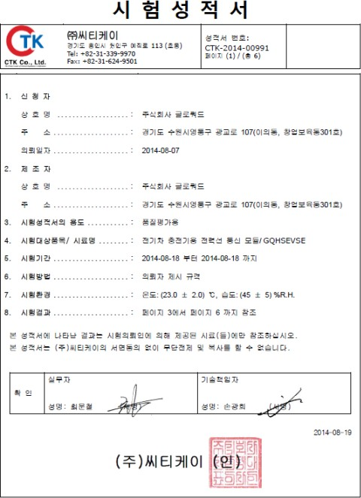9
PLC Throughput Test
Vibration Test Report (10-100Hz, 0.5 Oct/Min)

如何用ISO/IEC15118和GB/T 27930
开发CSS电动汽车联合充电解决方案

How to develop CCS EV Charging Solution wit
h ISO/IEC15118 and GB/T 27930

GB/T27930 VS ISO/IEC15118

*CCS: Combined Charging System

 | GB/T27930 | CCS (ISO/IEC15118)
PHY/MAC | CAN | PLC(HomePlug Green PHY)
AC/DC Charging | DC | AC/DC
Connector Lock | By Charger | By EV
When Insulation
test start | Just after exchange handshake | After exchange Charge parameters
 | Plugin à Lock à CHM/BMH à  insulation test by charger à CRM à | Plugin à CHM/BHM à CRM/BRM à  BCP/CML à BRO à CRO=0 à  Insulation test by EV à CRO=AA à
Charging Decision by | EVSE (Charger) Charger (EVSE) checks EV’s parameters for Charging | EVCC (EV)  EV checks Charger(EVSE)’s charge  parameters for Charging
When EVSE DC Relay ON | CRO=0 à DC relay ON à  CRO=AA à …  (charger ready to transfer energy) | CRO=0 à Insulation test à CRO=AA à  DC relay ON à …

11

CHAdeMO vs. ISO/IEC15118

 | CHAdeMO | ISO/IEC15118 CCS  (Combined Charging System)
Communication Interface | CAN (Serial) | PLC (Internet Protocol version 6)
AC/DC | DC only | AC/DC Combined
Pin Assignment | CAN+ CAN-  Charge sequence signal 1 (d1) Charge sequence signal 2 (d2) Vehicle charge permission (k) Connector proximity detection Ground  DC+  DC- | Control Pilot(CP)  Proximity detection Ground  DC+  DC-  AC Power (L1) AC Power (L2,N)

12

GB/T27930 CAN Signal for ISO/IEC15118

RNL需要实现新的GB/T27930 CAN信号以使国标GB/T27930的电动汽车充电桩 支持ISO/IEC1511
8电动汽车充电桩标准。客户需要在他们的SECC(电动汽 车充电桩控制板)上加上新的GB/T279
30 CAN 信号。RNL提供快速面向市场 的符合ISO/IEC15118的充电桩解决方案。

用于ISO/IEC15118接口的新GB/T27930 CAN信号
New GB/T27930 CAN Signal for ISO/IEC15118 Interface

MSG  Code | ID | Start bit | Length (b it) | Signal Name |  | description |  | Factor | offset | Range | unit | SPN
BHM | 182756F4 | 16 | 8 | CR_Plc_Aagvalue |  | Average Attenuation Gain, at start: 00, at end of SLAC:≠ 0 |  | 1 | 0 | 0 ~ 255 | - | New_1
 |  | 24 | 2 | CR_Plc_CpStatus |  | See reference |  | 1 | 0 | 0 ~ 7 | - | New_2
BCP | 1C0656F4  (with TP, PGN=0x000600) | 104 | 4 | CR_Plc_EvTransferType |  | Supported Energy Type (default 3, see appendix) |  | 1 | 0 | 0 ~ 15 | - | New_3
BST | 101956F4 | 30 | 1 | CF_Plc_FullChgComplete |  | 0: not Full 1: full charging complete |  | 1 | 0 | 0 ~ 1 | - | New_4
 |  | 31 | 1 | CF_Plc_ChgFinished_ |  | 0: charging, 1: charging stop request |  | 1 | 0 | 0 ~ 1 | - | New_5
`BSD | 181C56F4 | 56 | 1 | CF_Plc_WeldDetectionReq |  | 0: no welding detection 1: welding detection request |  | 1 | 0 | 0 ~ 1 | - | New_6
BEM | 181EF456 | 48 | 8 | CR_Plc_ErrorCode |  | PLC Error Code |  | 1 | 0 | 0 ~ 255 |  | New_7
 |  | 56 | 3 | CR_PLC_EvErrCode |  | EV error Code, see appendix |  | 1 | 0 | 0 ~ 15 | -
CHM | 1826F456 | 24 | 4 | CR_Secc_EvseTransferType |  | Supported Energy Type (default 3, see appendix) |  | 1 | 0 | 0 ~ 15 | - | New_8
 |  | 28 | 1 | CF_Secc_StartPlc |  | 0: PLC wait to start 1: PLC start chargeing seq. |  | 1 | 0 | 0 ~ 1 | - | New_81
CSD | 181DF456 | 16 | 16 | CR_Secc_OutEnergy |  | 0 (no value with CCS) , Output Energy |  | 0.1 | 0 | 0~1000 | KWh | 3612
 |  | 16 | 16 | CR_Secc_EvseOutVolt |  | Voltage output value |  | 0.1 | 0 | 0~6553.5 | V | New_9

13

ISO/IEC 15118 和GB/T 27930配置概述

EV Charger
Charger Board (SECC)
(GB/T27930)

DC+

DC- CP
GND
GB/T27930 CAN

Inlet
(J1772)

DC+

DC- CP
GND PD
EV Car

BMS
(GB/T27930)
GB/T27930 CAN

DC12V CAN- CAN+
DC24V
CAN- CAN+

GB/T27930 CAN to
CCS Protocol Converter

GQ EVSE
GB/T27930 CAN to
CCS Protocol Converter
PLC Board
GQ EVCC
PLC Board

RNL 提供给客户简单方便，快速面向市场的ISO/IEC15118充电通讯软硬件解决方案。

EV充电桩配置参考

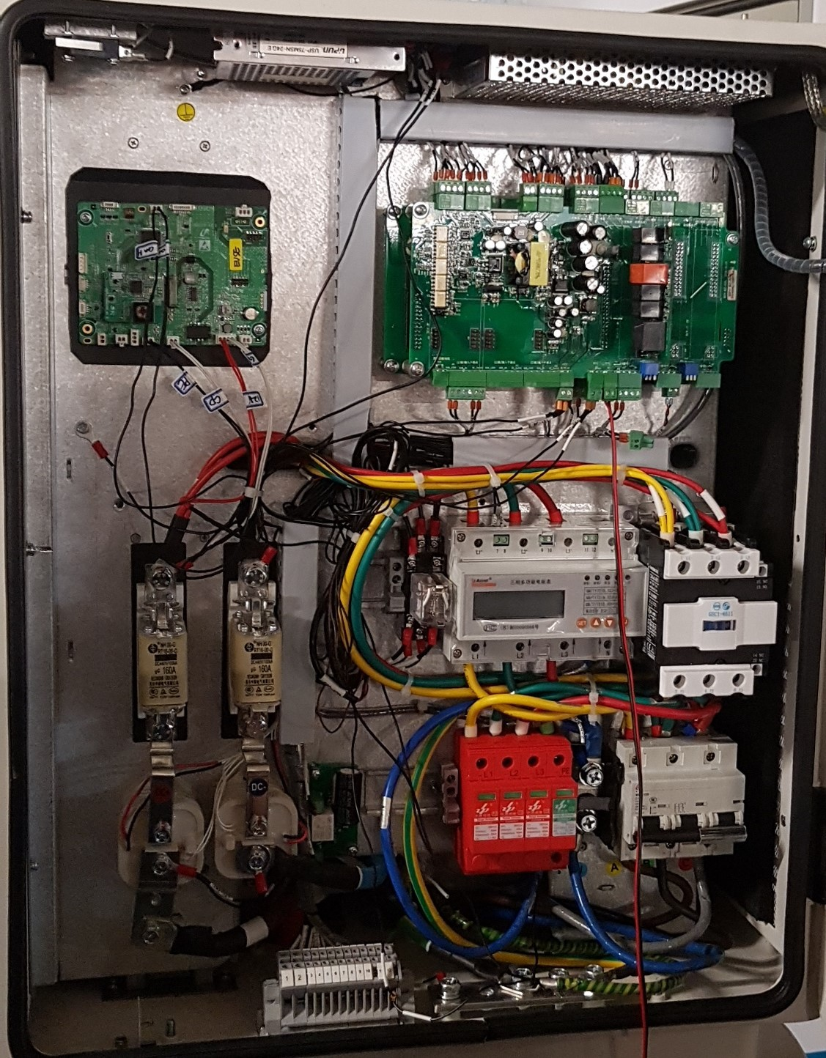GQ’s EVSE board Customer’s GB/T27930
Charger Controller Board (SECC)

CAN: GB/T27930-2015

用户界面

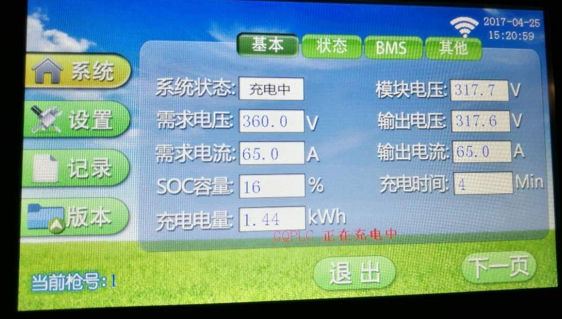
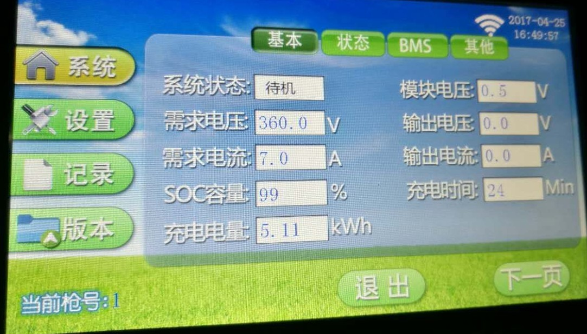
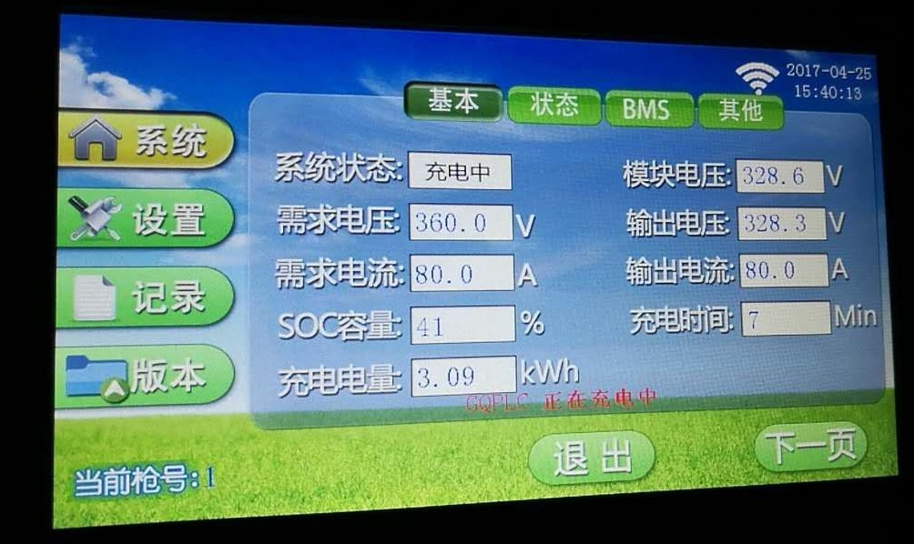

16

开发工具组配置
SECC: GB/T27930 Simulator

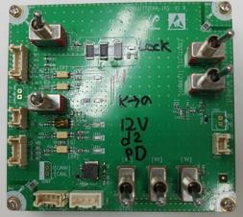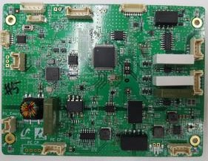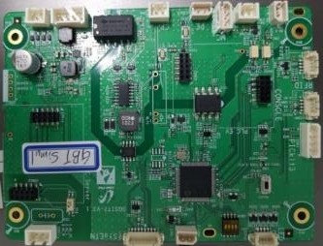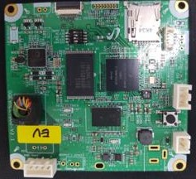EVCC: GQ EV Simulator

GQJ1772CHA-JIG
CAN(GBT ßà CCS)

EVSE: GQEVSE32PLC-12V, 24V

Voltage level change

CP/PE

开发工具组配置

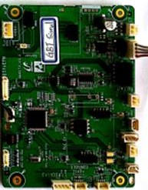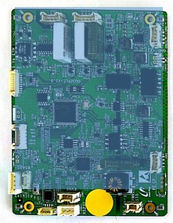
J1772 Simulator board
CP
PE
Control Pilot
PE(GND)
EVCC/PLC
GB/T 27930
CAN Signal
GB/T27930
Simulator (SECC)
EVSE / PLC
EV Charger

GQJ1772CHA-JIG 板模式选择

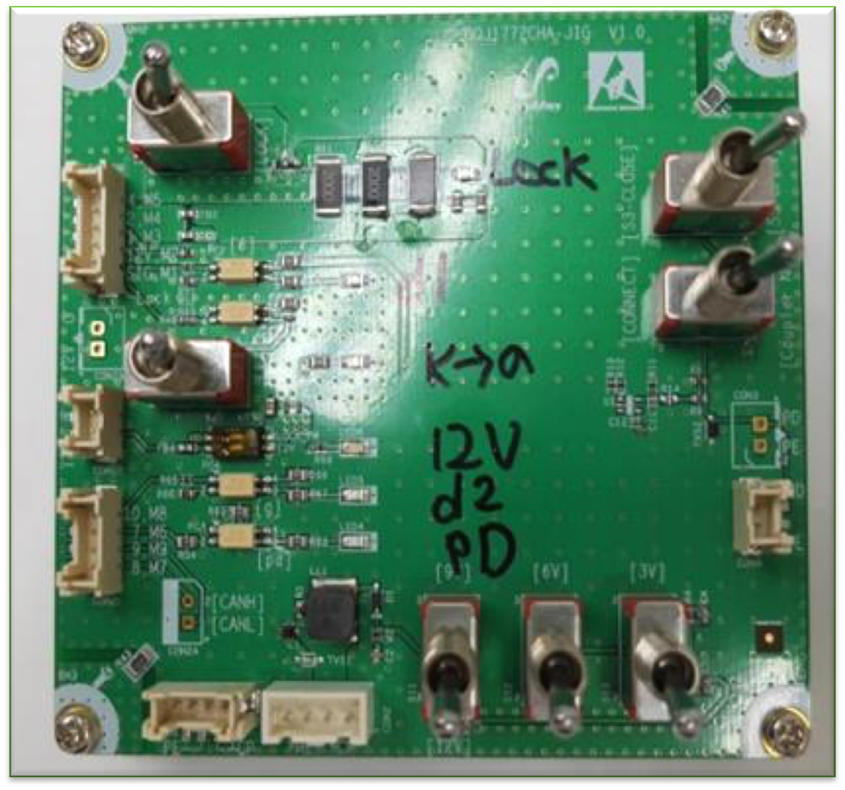
Plug-in
Un-plug
Switch pressed

附录

充电状态图 Charging State Diagram

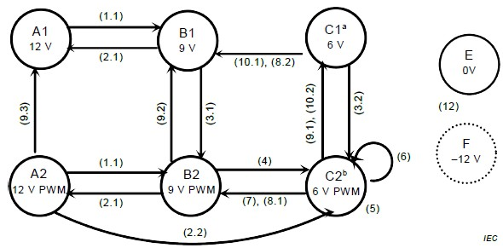State A1: Un-plugged 未插入
State B1: Plugg-In & EVSE not ready 插入&EVSE未准备
State C1: B-C-B toggle function started by EV 由Ev启动B-C-B 切换功能
State B2: EVSE ready to transfer energy EVSE准备传输能量State C2: Charging充电

Un-plugged Plugin

Charging

- 1.1 : Plug-in 插入
- 2.1 : Unplug at state Bx (x == 1 or 2, Bx == B1 or B2 )在状态Bx
时未插入
- 3.1: EVSE power available (state B) EVSE电源可用（状态B）
- 3.2 : EVSE power available (state C) EVSE电源可用（状态C）
- 4 : EV ready to charge Ev准备充电
- 7 : EV stops charging Ev停止充电
- 8.1 : EVSE responds to EV opens S2 (with PWM)

- 6 : current charging
- 9.1 : EVSE requests to stop charging EVSE请求停止充电
- 10.2: EV does not respond to a stop charging request
- EV未响应停止充电请求

充电序列中的CP状态(I) Charging Sequence Control Pilot Status

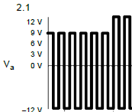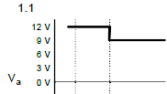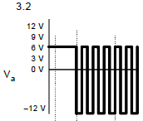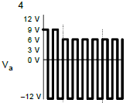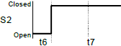1.1 插入Plug-In

2.1 : Bx状态下未插入 Unplug at state Bx
3.2 : C状态下的EVSE电源可用. _{EVSE} power available (state C)

- : EV 准备充电 EV ready to charge

充电序列中的CP状态(II) Charging Sequence Control Pilot Status (II)

- : Charging充电
8.1 : EVSE responds to EV opens S2 (with PWM)
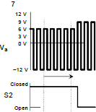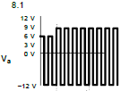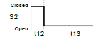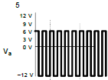EVSE回应Ev（通过PWM）打开S2

7 : EV stops charging Ev停止充电

DC Level2系统示例 System Example
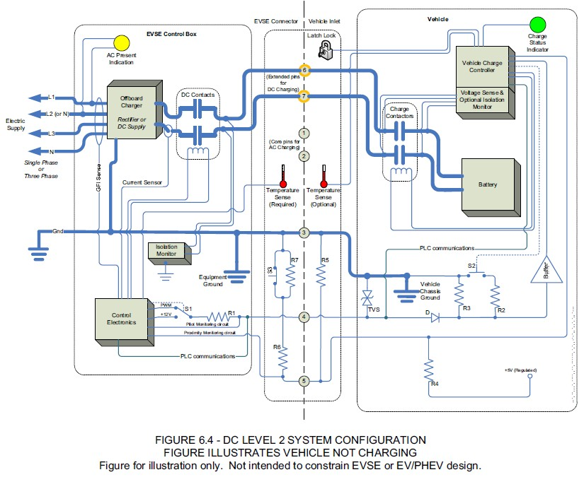

任何疑问或需求，请联系：

RNL总经理 练先生
Mob：13510012282
Email：lian@rocknoo.com

25

